所有武器

**小刀**

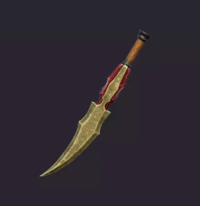

链接：[FREE - Stylized Weapons | 3D 武器 | Unity Asset Store](https://assetstore.unity.com/packages/3d/props/weapons/free-stylized-weapons-216047)

操作：左键攻击

**匕首**

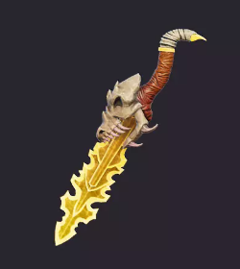

链接：[FREE - Stylized Weapons | 3D 武器 | Unity Asset Store](https://assetstore.unity.com/packages/3d/props/weapons/free-stylized-weapons-216047)

操作：左键攻击，右键扔出（扔出有伤害，消耗一把匕首）

**铁剑**

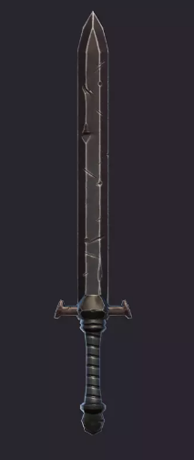

链接：[FREE - Stylized Weapons | 3D 武器 | Unity Asset Store](https://assetstore.unity.com/packages/3d/props/weapons/free-stylized-weapons-216047)

操作：左键轻击，右键重击

**木盾**

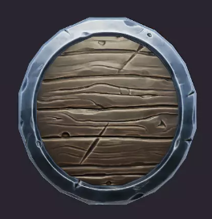

链接：[FREE - Stylized Weapons | 3D 武器 | Unity Asset Store](https://assetstore.unity.com/packages/3d/props/weapons/free-stylized-weapons-216047)

操作：左键防御

耐久：100